**TITLE: Understanding the Transmission Dynamics of Antimicrobial Resistance at the Human/Livestock Interface**

**INTRODUCTION**

* Need to define what a model is and why they are useful
* Might want to mention why we chose these two types of model?

**SYSTEMATIC REVIEW METHODOLOGY**

A search strategy was developed to identify all quantitative mathematical models describing the zoonotic transmission of AMR between livestock and humans. The search was focused on identifying relevant risk assessments and dynamic population models. The risk assessment search designed to be as inclusive as possible with all four stages of the risk analysis considered. Similar steps were taken with the search terms for the dynamic population models to include a large range of possible terminology.

To specify the results of the model search to bacterial resistance to antibiotics, a list of antibiotic classes specified by the English Surveillance Programme for Antimicrobial Utilisation and Resistance (ESPUAR) report was used. Resistance to non-bacterial pathogens and disease **()**, were explicitly excluded from the search. A full list of search terms are specified in the appendix **()**.

Using these search terms, a search was conducted using PubMed and Web of Science search engines. A grey literature search was also conducted to identify relevant non-peer reviewed government reports. This search was performed by searching government and non-government archives, including and not limited to the World Health Organisation (WHO), Food and Agriculture Organisation (FAO), Food and Drug Administration (FDA) and Public Health England (PHE). This search was conducted using Google search and internal site searches. After removal of duplicate studies, 10,053 studies were considered for a Title/Abstract screening process.

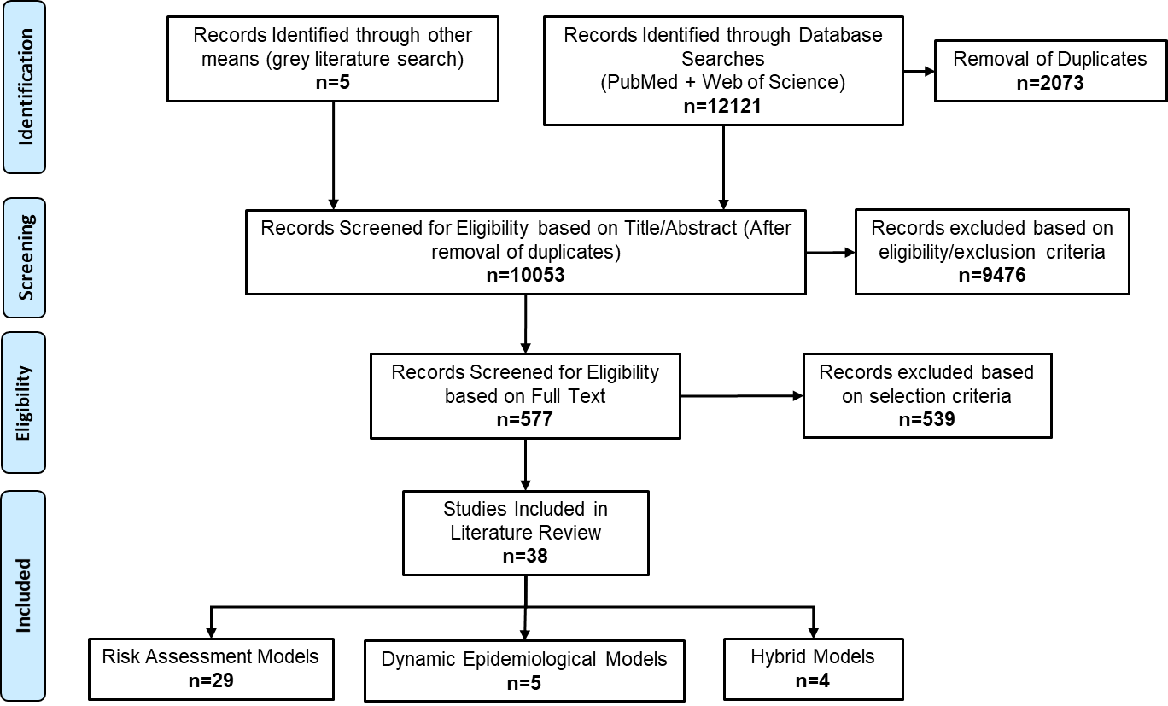

**FIGURE 1 – PRISMA Flowchart for Study Inclusion**

A set of inclusion and exclusion criteria were selected for this review as part of an overall screening process to identify relevant papers. Consistent with the aim of this review, studies were removed which did not refer to the use of dynamic population models or risk assessment type methodologies, and did not directly reference the modelling of antimicrobial resistance. Different variants of these terms were also considered as a part of the screening process. A comprehensive list of these permutations can be found in the review search terms **()**. Studies which focused on within-host bacterial dynamics, companion animals, pharmacodynamics modelling, population genetics and non-bacterial resistances **()** were excluded from this review. Literature reviews with non-novel results, studies with a focus on statistical models and non-English language studies were also excluded.

After an initial Title/Abstract screening step, full-text papers were assessed for final inclusion in the review based on if the study was a quantitative outlook on the transmission of AMR between livestock/humans and if the identified risk assessments met a set of three criteria, described by Caffrey et al, (2018) as a quality control step (Appendix). It was not a requirement for the studies to describe or model the entire farm-to-fork pathway, with mathematical models also being included if they include the influence from intermediate stages of the farm-to-fork pathway **()**. However, to be considered for inclusion in this study, these studies must have implied the presence of AMR in these intermediate pathways being due to agricultural processes at the farm-level.

A data extraction process was then undertaken for included studies, with a database being curated to record the details of each study. After extracting and descriptively categorising the data from these studies, an abbreviated “import-friendly” version of the database was created and imported into R for data-analysis (R-Studio).

**RESULTS**

* Focus more on describing the data and limitations with thing slike lack of population modelling and spatial livestock heterogeneity – but I need to keep sections brief for a single section

General Model Characteristics

This scoping review identified 38 relevant quantitative mathematical models which describe the zoonotic transmission of AMR bacteria between livestock and humans **(Appendix – List of Studies)**. Based on the model outcome measure, these studies were categorised as a risk-assessment (n=29), dynamic population model (n=5) or a hybrid model (n=4). Models were considered a risk assessment if the main outcome of interest was to identify the risk of an adverse health event occurring to an at-risk human population from a specific AMR hazard. Examples of potential risk measures include individual/population risk, per-meal risk and annual risk based on consumption **()**. Models were classified as a dynamic population model if the main outcome measure was to investigate the population dynamics underlying AMR transmission. These studies often model the transmission of disease through a simulated population at the individual (agent-based) or sub-group (compartmental) level. A number of studies used a combination of risk assessment and dynamic population model outcome measures (e.g – use of population-level compartmental model output in a risk calculation) and were identified as “hybrid” models, due to the significant overlap in the outcome measures used.

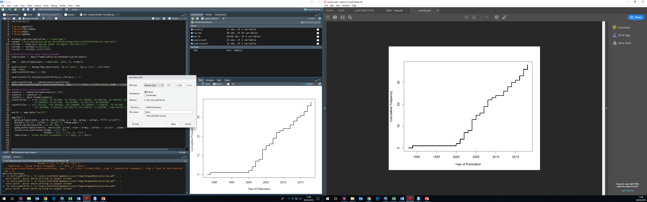

**FIGURE 2 – Year of Publication for Articles included in Study (n=38)**

The publication date of these studies ranged from 1989 to 2018, with the vast majority of articles being published from the 2000s onwards (n=37) **(Figure 2).** The majority of the identified articles originated in the United States (n=23), with studies from Europe (n=8) and Asia (n=4) being the second and third most numerous. A small number of Canadian (n=2) and South African studies (n=1) were also identified **(Figure 3)**. Peer-reviewed journals were the most common source of included studies (n=34), with a number of grey-literature papers also being identified (n=4).

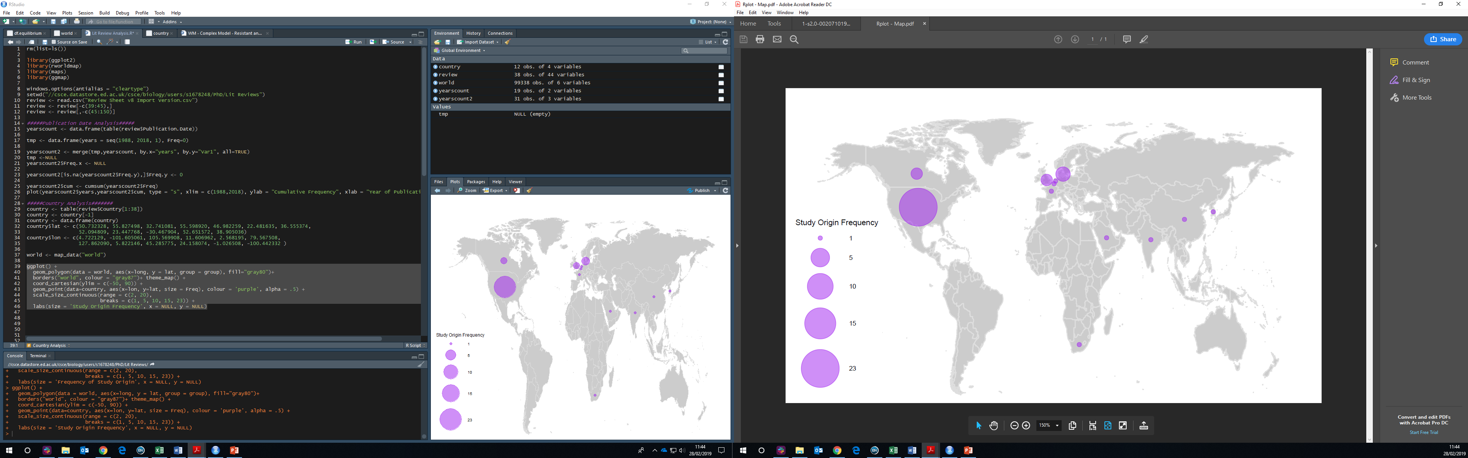

**FIGURE 3 – Country of Origin for Included Articles in this Study (n=38)**

The majority of studies focused on “traditional” foodborne bacterial pathogens, which are commonly identified by transient symptomatic infection after a brief exposure period in the majority of cases. This includes *Campylobacter* spp. (n=14), *Salmonella* spp. (n=10) and *E.coli* serotypes (n=7). A large number of studies also modelled “non-traditional” foodborne bacteria (e.g – transmission of bacteria commonly found as human commensal bacteria). These include *Enterococci* spp. (n=11), *Staphylococcus* spp. (n=2), *Klebsiella* spp (n=1) and *Acinetobacter* spp. (n=1). These studies were mostly concerned with the spread of AMR determinants through bacteria of a livestock origin to human commensal bacteria and the future risk of opportunistic infection. A number of papers did not specify the bacteria species of interest (n=3) and several studies modelled the transmission of more than one species of bacteria **(n=…)**.

The majority of included articles modelled “non-specific” antibiotics, with general non-specific antibiotics being modelled (n=12). For studies which specified the class of antibiotic used, a large range of antibiotic classes were represented, these include streptogramins (n=7), macrolides (n=6), fluoroquinolones (n=6), cephalosporins (n=4) and penicillins (n=4), tetracyclines (n=4) and glycopeptides (n=2). A number of studies also included the influence of more than one antibiotic in the model.

The most commonly modelled transmission route at the livestock/human interface was livestock-to-food-to-human (n=18). However, a large number of studies modelled the food-to-human transmission route (n=15), with AMR found in foodstuffs implicitly modelled as a result of agricultural antibiotic usage. This “food-to-fork” modelling approach was often undertaken by these studies due to a stated lack of empirical data to quantify the contamination of AMR bacteria from livestock-to-food. A small number of studies also modelled reverse-zoonosis of foodborne bacteria through human-to-livestock transmission pathways (n=2). Several studies modelled the direct transmission of AMR bacteria from livestock-to-humans (n=8), often through farmworker contact to livestock in agricultural settings. Only 2 papers modelled the transmission of AMR bacteria from the environment-to-humans, with the influence of agricultural antibiotic usage either modelled implicitly or explicitly. Many of the included studies also modelled the transmission of AMR through more than 1 transmission route **(n=…)**.

Poultry (and poultry associate foodstuffs) were the most common livestock species modelled (n=15), with a large number of studies modelling non-specific livestock species to capture transmission dynamics in a generic animal population (n=12). Cow and pig populations were modelled in equal frequency with 8 each (n=16). AMR contamination of vegetables, general foodstuffs and water sources were also modelled in a small number of studies (n=4), with the AMR bacteria in these sources implied to be as a result of agricultural contamination.

Model Structure

To further identify the range of modelling approaches used, the identified studies were assessed further based on their implemented model structure. For ease of categorisation, this process was based on the previously identified groupings of the model outcome measure, with each of the three model outcome types being broken down into further sub-groups based on the model structure used.

Dynamics Population Models

* Describe the resulting dynamics and possible positives for each model.

A deterministic compartmental model structure was used in all dynamic population models included in this study **(n=5)**. Compartmental models are often used to represent transmission between different sub-groups, with individuals in each “compartment” possessing a specific disease state and transmission occurring to a “pool” of susceptible individuals. Often this will be expressed in terms of fractions of the human/animal population belonging to each group. The most commonly modelled compartment was an antibiotic-resistant infection state **(n=…)**. Antibiotic-sensitive bacterial infection was included as a compartment in only one study. General foodborne illness was also modelled in human and livestock populations **()**, with livestock antibiotic usage reducing levels of illness in livestock (i.e – necrotic enteritis), but with antibiotic susceptibility states of infection not being explicitly defined.

All identified compartmental models followed a basic SI or SIS model structure, with “recovery” back to a susceptible state being possible in a number of studies, with the susceptible compartment often being simplified into a fraction to reduce model complexity. Due to the biological implausibility of immunity to foodborne infection and the transient nature of an exposure period, no studies included a recovered or exposed state. Antibiotic treatment status was used to define compartmental model structure in a small number of studies **(n=…)**. For example, a hospital population can be sub-divided based on both antibiotic treatment status and whether or not the individual is colonised by a foodborne pathogen **(Kelly et al, 2004)**. This is especially relevant in hospital models, where the use of antibiotics may be greater than in the community.

**FIGURE - Have a figure here with the different types of compartmental models**

Rates were used by a number of studies to indirectly model the influence of AMR in the livestock population, and the subsequent transmission to humans. An example of this includes the use of an agricultural antibiotic usage (AAU) rate, describing the indirect influence of antibiotic usage in livestock and subsequent transmission to human populations (**Smith et al, 2002**). Population fractions were similarly used to represent the prevalence of AMR colonisation in livestock to determine the magnitude of AMR transmission to human populations. An alternative approach includes explicitly modelling the livestock populations through separate dynamic compartments. This captures the dynamic nature of livestock infection, which has a large impact on the transmission dynamics in human populations. This approach is often used to assess the effects of AMR interventions strategies in livestock populations and the subsequent effects on human infection (**van Bunnik and Woolhouse, 2017**).

**Figure 4 – HAVE A LARGE FIGURE WITH A GENERAL OVERVIEW OF THE COMPARTMENTAL MODEL TYPES**

* Might be cool to talk about the different types of models which haven’t been included – like individual based models (Maybe talk about why they aren’t included)
* Often these model types will have a risk calculation at the end (not sure whether to add this into the hybrid calculation section).
* Need to mention the different characteristics of the models and how they treat transmission – 1 animal infects 1 human? (this would be the per capita exposure rates)

Risk Assessment Model Structures

* Mention the inclusion of dose response relationships

Risk assessment is defined by the Codex Ailementarius guidelines as being a quantitative evaluation of the potential public health risks from exposure to various agents **()**. With further codex guidelines identifying 4 steps which are necessary for risk assessments: (name the four steps of the process).

Farm-to-fork models adhere most strongly to codex guidelines for a risk assessment, with the exposure pathway clearly described. These models often describe the probability of AMR transmission at all processes from livestock to humans, and the probability of exposure to human populations. A significant number of risk assessment studies followed this structure (**n=…**). Variations on this approach include a food-to-fork model, which begins the risk assessment at the post-slaughter stage, often due to potential data limitations with the preceding livestock stages. This approach was used by a small number of included risk assessments (**n=…**).

An alternative to farm-to-fork risk assessment approaches are attribution models (**n=…**). These risk assessments require a pre-identified risk to human health from the AMR hazard to be established at the beginning of the analysis (i.e – Number of clinically relevant AMR cases per year), with different approaches being used to apportion this AMR risk to different sources, ranging from animal sources or antibiotic usage. The attribution approaches range from Bayesian or stochastic methods (**n=**) to simpler deterministic attribution models (**n=**…). A similar approach includes a rapid risk rating technique, which specifically tries to attribute the risk to antibiotic usage in livestock, but with a risk/benefit ratio being used to determine the effects of antibiotic usage on this human-health risk (**n=…**).

Direct risk calculations are the simplest type of risk assessment, often using simple fraction-based calculations from epidemiological data or collected empirical data to determine the estimated the risk associated with the AMR hazard of interest. A total of **(n=…)** included studies used these simple calculations, of which **(n=…)** used epidemiological data, and **(n=…)** were as a result of microbiological experimental data. An example includes the use of microbiological and phylogenetic analysis of *A.baumanii* to determine the presence of the resistant strains in vegetables, which was then fed into a simple risk-model to determine annual risk to humans **(Toh et al, 2018)**.

Dose-response models were often used in risk-assessment models to determine the relationship between bacterial dose ingested and the likelihood of human infection **(n=),** with the primary model used being the stochastic Beta-Poisson model from **Haas (1983)** and **Medema et al (1996)**. The implementation of these models in the included risk-assessments range from full implementation of the stochastic model dynamics to model varying bacterial dose per ingestion **(n=…)**, to fixed likelihoods of infection obtained by specifying an average number of ingested organisms, often to simplify model parameterisation **(n=…)**.

Hybrid Models

A small number of included studies were “hybrid” models **(n=4)**, with these models being an integrated mix of both dynamics population model and risk assessment type model structures. An example includes an integrated model used by **Kelly et al. (2004)**, with this model using a probability based exposure assessment to determine the rate of exposure to chicken-borne streptogramin-resistant *E.faecium* (SREF). This rate is then used in a compartmental model to determine the prevalence of hospital SREF after a livestock antibiotic usage ban. An alternative approach was used in **Cox et al. (2014)**, using a dynamic compartmental model to determine a reproductive rate for ST398 MRSA which was used in a risk-model to determine the attributable risk of human MRSA infections in the US to direct contact with pigs.

Modelling the Effect of Interventions

Data Used and Model Validation and Sensitivity Analysis Used

Model parameterisation and validation are two fundamentally different conepts, with model parameterisation being used for use in model fitting to determine parameter values and value ranges. Model validation involves the use of statistical model fitting approaches to assess accuracy of model data

overall risk assessment approach which attributes a risk to human health from

* Need to think about whether or not the risk assessment strcutre is a proability based one or can it also be a deterministic model structure, but with the model using deterministic fixed values in the calculation.

these studies being split into either compartmental models (n=4) or risk assessment model structures (), with either of these models significant overlap between the two types of models. These models are no longer categorised based on the model output

This overlap occurs due to model output

* Do a comparison of strain specific vs general models benefits and disadvantages
* Need to address the overlap and why I am including two model types (compartmental and risk assessment – and what is the overlap between them).